**Outline**

1. **French to English**
2. **Calibration**
3. **Clearing magnification / Calibration**
4. **Measurement**
5. **Further assistance**

French to English

In case the program is opened and in French its important to put it to the language you prefer.

**Step 1:** Selected options from the top bar and go to Préferences….

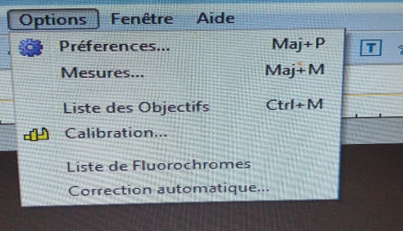

**

**Step 3:** Selected preferred langue and press ok

**Step 4:** Close and re-load application

Calibrating the microscope

**Step 1:** Place specimen under the microscope and utilize the knops to get preferred depth and clarity of the area desired to measure

**Step 2:** Remove object and put on calibration slide. Without adjusting the knobs (clarity and depth) make sure the slide is centered in the microscope.

**Step 3:** Selected desired camera under Camera List



**Step 4:** Make sure the upper bar is set to Pixel, NA, 100% for calibration. Calibration will not work if not in this setting



**Step 5:** Hit the calibration button which looks like , in the upper tool bar



Or go under Options and hit the calibration button

**Step 6:** This will pull up the calibrate window, in the magnification slot select 10X, for the actual length enter the length of the scale bar that is in the window. (Entire scale bar equals 1 mm), adjust the units as needed.

Note – the actual length cannot be decimals and must be a whole number

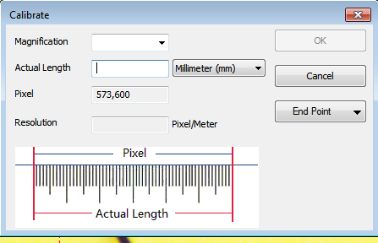

**Step 7:** adjust the bars on the screen to the length you put under the actual length, and then hit OK.

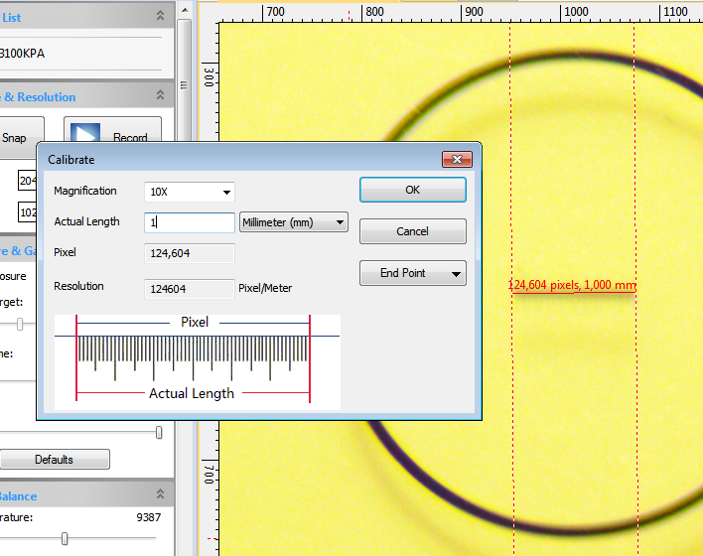

**Clearing magnification / Calibration**

To clear the calibration or to re-do it

**Step 1:** Go to Options and hit Magnifications

**Step 2:** Hit Clear all then hit OK. If you don’t hit OK, it won’t be clear

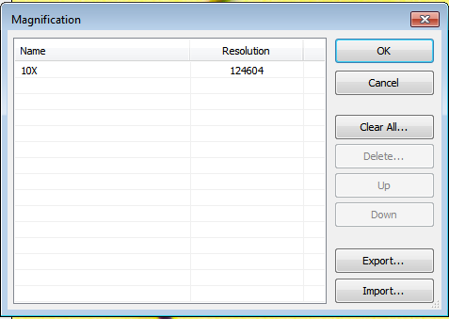

**Measuring the Larval**

**Step 1:** Calibrate the microscope and the program (see steps above)

**Step 2:** Using the dark side of the disk, place a piety dish with a drop of water in the center and a small puddle on one of the sides. The center water drop is to set of the larval for the picture and the side water is to store the larval after measuring

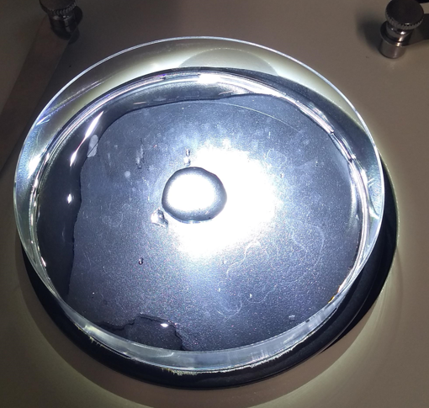

**Step 3:** Remove a larval and identify it to be herring or not herring

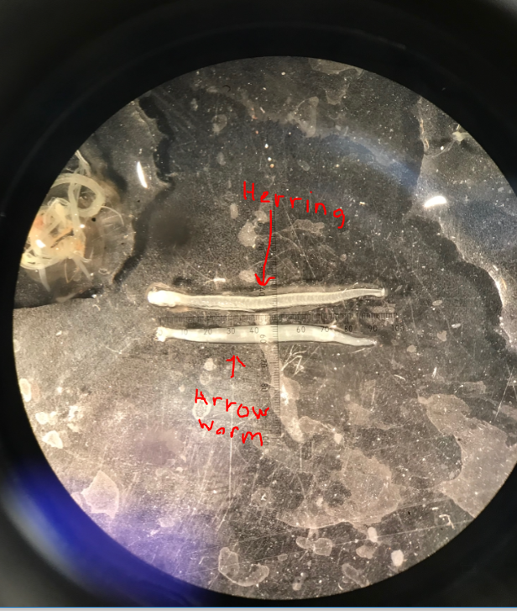

**Step 4:** If herring set up the herring in the Petri dish, allowing the herring to be in a liner fashion within or outside of the water. If outside of the water, it is important to be quick as they are easy to break

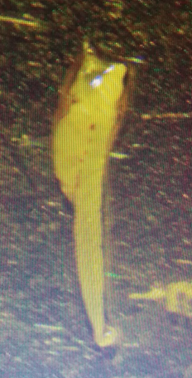

**Step 4:** Take a picture of the herring larval by hitting the F8 button or the snap button on the left-hand side or go under capture and hit Capture image.

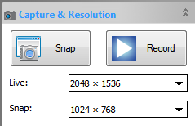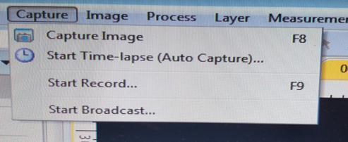

**Step 5:** Load up the arbitrary line tool. Arbitrary lines can be found by going under Measurements – Line – Arbitrary Line or on the upper tool car under the line icon.

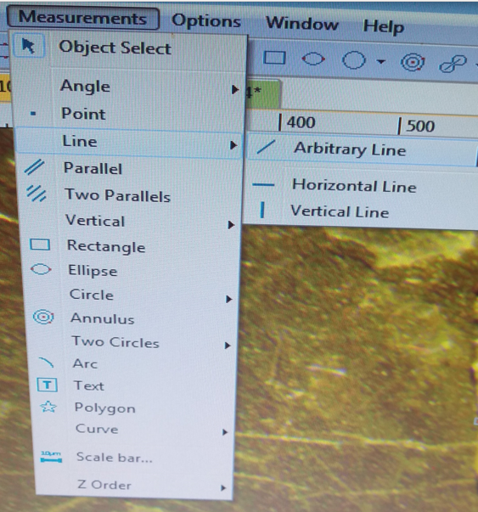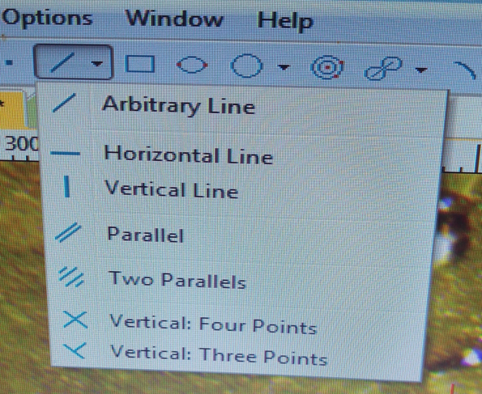

**Step 6:** Place an arbitrary line along the center of the Herring’s body from the head to the tail, if there are arcs or turns place multiple lines. If multiple lines make sure to start and end lines in the same location, you can then add the lines together or change the object type to the same object type. Its calculated items will depend on the selected Object type (The type could be the same or different).

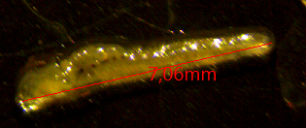 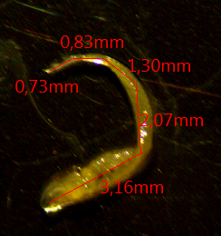

**Step 7** : If there is an yoke Sac take a measurment of it too

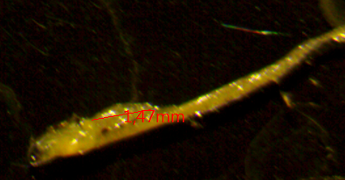

**Step 8:** Save the picture under the sample ID.Larval number (Ex SB2018-08.01)

**Further assistance look at the manual under help, help contents (F1)**

